**Course Specialist Test 2 Year 12**

Student name: ________________ Teacher name: ________________

**Task type: Response/Investigation**

**Reading time for this test : 5 mins**

**Working time allowed for this task: 40 mins**

**Number of questions: 7**

**Materials required:** Upto 3 classpads/calculators

Standard items: Pens (blue/black preferred), pencils (including coloured), sharpener, correction fluid/tape, eraser, ruler, highlighters

Special items: Drawing instruments, templates, notes on one unfolded sheet of   
A4 paper SINGLE SIDED, and up to three calculators approved for use in the WACE examinations

**Marks available: 40 marks**

**Task weighting: 13%**

**Formula sheet provided: no but formulae stated on page 2**

**Note: All part questions worth more than 2 marks require working to obtain full marks.**

**Useful formulae**

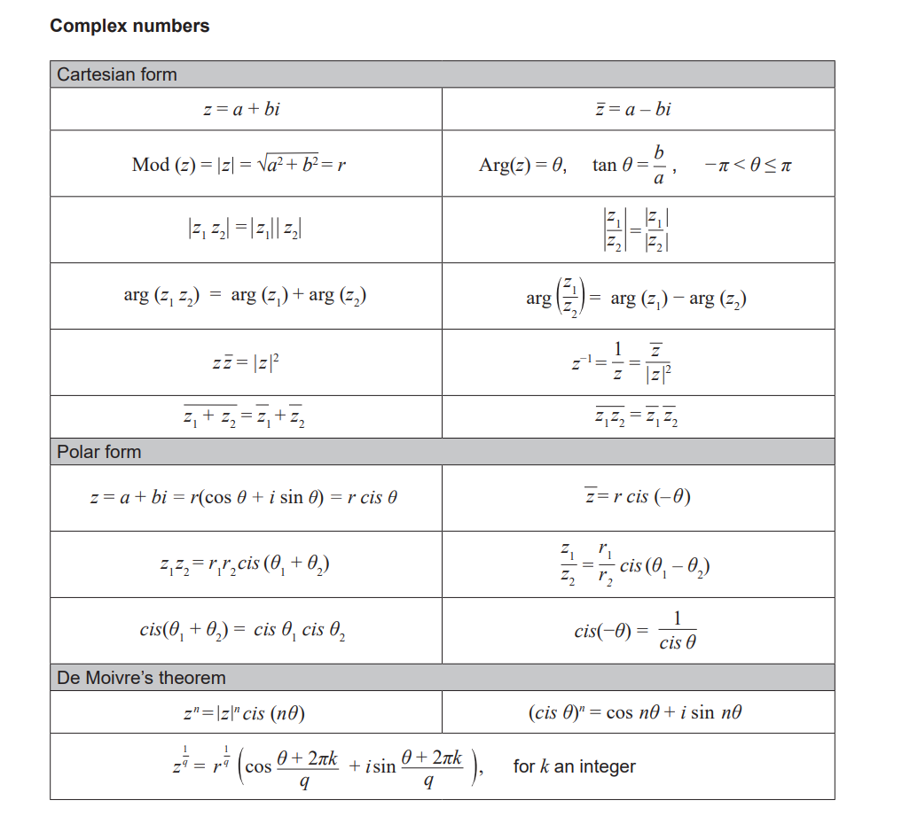

 Q1 (3 marks)

Consider the inequality  which is only true for  where  are constants.

Determine the values of .

|  |
| --- |
| **c** |
|  |
| **Specific behaviours** |
| 🗸 rearranges inequality by taking out factor of 3 or sketches and shows reasoning  🗸 determines a  🗸 determines b |

Q2 (4 marks)

|  |
| --- |
| **c** |
|  |
| **Specific behaviours** |
| 🗸 takes into account different starting times  🗸 sets up two equations for time  🗸 solves for position of collision  🗸 solves for time of collision in clock time |

Q3 (2, 3 & 3 = 8 marks)

1. Sketch  on the axes below.

|  |
| --- |
| **c** |
|  |
| **Specific behaviours** |
| 🗸 shape  🗸 correct x & y intercepts |

1. Sketch  on the axes below.

|  |
| --- |
| **c** |
|  |
| **Specific behaviours** |
| 🗸 uses reflection of left side or original  🗸 shape  🗸 correct x & y intercepts |

1. Sketch  on the axes below.

|  |
| --- |
| **c** |
|  |
| **Specific behaviours** |
| 🗸 vertical and horizontal asymptotes  🗸 approx. y intercept  🗸 shape in all 3 sections |

Q4 (2, 3, 1 & 3 =9 marks)

Consider  for  which is plotted below.

1. Sketch  on the axes above.

|  |
| --- |
| **c** |
|  |
| **Specific behaviours** |
| 🗸 contains endpoint (1,2)  🗸 appears reflected in line y=x |

1. Determine the rule for showing full working and the domain.(Simplify)

|  |
| --- |
| **c** |
|  |
| **Specific behaviours** |
| 🗸 swaps x and y  🗸 solves for y with reasoning  🗸 uses minus in rule and states domain |

Q4 cont-

1. Determine .

|  |
| --- |
| **c** |
|  |
| **Specific behaviours** |
| 🗸 states x |

1. Determine all value(s) of  such that 

|  |
| --- |
| **c** |
| Discard x=2.77 as not within domain of f(x) |
| **Specific behaviours** |
| 🗸 equates g(x) to x  🗸 sets up an equation to solve for x  🗸 solves for one approx. value and states that the second value MUST be discarded  Note: 2 marks max if using classpad to solve function=inverse without reasoning |

Q5 (5 marks)

Determine the minimum distance between them **using vectors** and the time that this occurs.

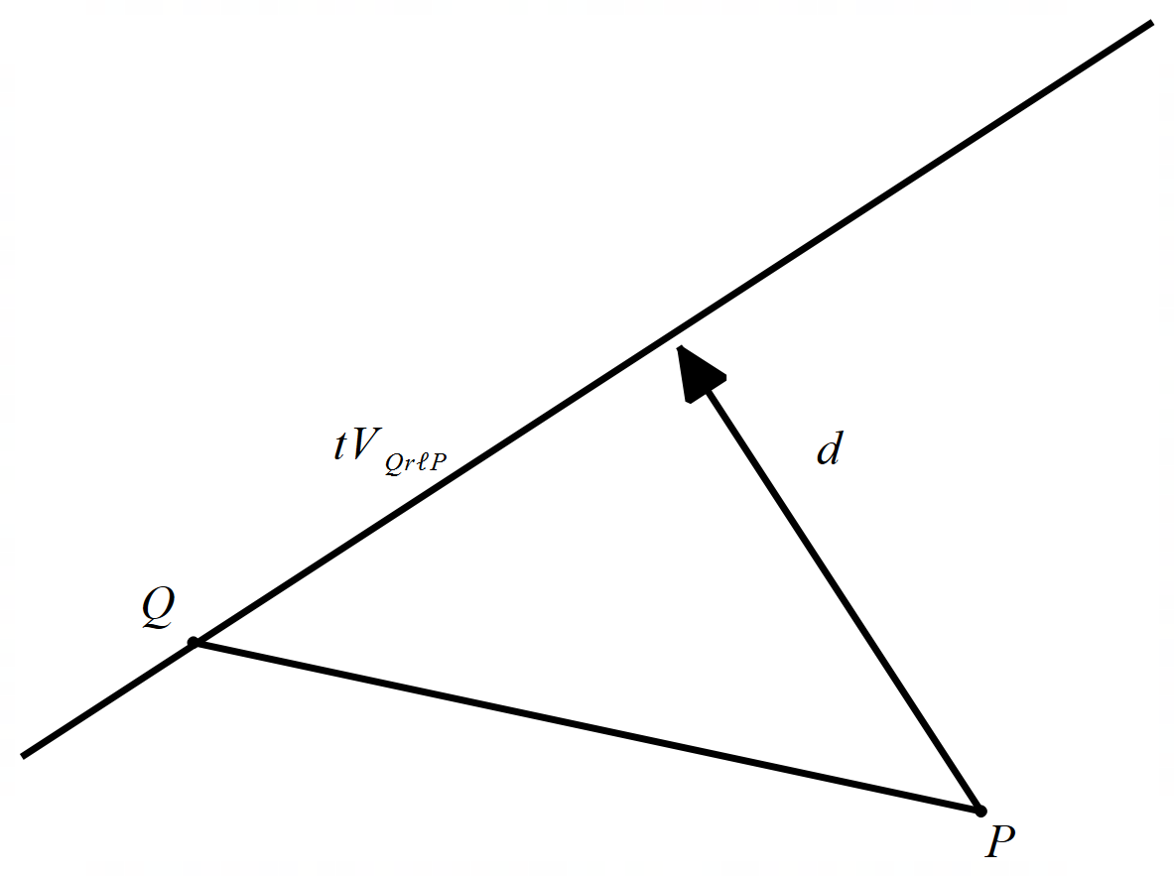

|  |
| --- |
| **c** |
| Distance = 10.05 metres at time 1.28 seconds |
| **Specific behaviours** |
| 🗸 uses relative velocity  🗸 determines a separation vector d  🗸 uses dot product and equates to zero  🗸 solves for time stating in seconds  🗸 solves for distance stating in metres  Note: max -1 if units not stated  Max 3 out of 5 if vector method not used |

Q6 (5 marks)

1. The line will be a tangent to the circle.
2. The line crosses the circle at two points.
3. The line will never meet the circle.

|  |
| --- |
| **c** |
| |  |  | | --- | --- | |  |  |  1. Alpha=-8.03, 10.53 2. -8.03 <alpha< 10.53 3. Alpha< -8.03, alpha> 10.53 |
| **Specific behaviours** |
| 🗸 subs line into circle  🗸 sets up a quadratic equation for lambda  🗸 determines an expression for discriminant in terms of alpha  🗸 states values for tangent **with discriminant = zero (stated)**  🗸states values for intersecting at two points AND no intersection and states conditions for discriminant.  Note: max -1 if discriminant values not stated |

Q7 (2 & 4 = 6 marks)

1. Represent this information on the Argand Diagram below.

|  |
| --- |
| **c** |
|  |
| **Specific behaviours** |
| 🗸 shows z in second quadrant with magnitude of 10  🗸 shows w in first quadrant with k being horizontal |

1. Determine a simplified expression for  in terms of . Justify your answer.

|  |
| --- |
| **c** |
|  |
| **Specific behaviours** |
| 🗸 identifies symmetry of triangles  🗸 uses cosine rule or other trig identity  🗸 obtains expression for k squared  🗸 states simplified expression for k in terms of theta with a negative |